Buckshaw Primary School


SEND INFORMATION REPORT
April 2025
SENDCO: Mrs I Albustany
Email: i.albustany@buckshaw.lancs.sch.uk

CONTENTS

- AIMS
- THE KINDS OF SPECIAL EDUCATIONAL NEEDS FOR WHICH PROVISION IS MADE AT BUCKSHAW
- IDENTIFYING PUPILS WITH SPECIAL EDUCATIONAL NEEDS
- CONSULTING AND INVOLVING PARENTS AND PUPILS
- ASSESSING AND REVIEWING PUPILS’ PROGRESS TOWARDS OUTCOMES
- ARRANGEMENTS FOR SUPPORTING PUPILS MOVING BETWEEN PHASES OF EDUCATION AND PREPARING FOR ADULTHOOD-INCLUSIVE OF COVID-19 SCHOOL CLOSURES.
- OUR APPROACH TO TEACHING PUPILS WITH SEND
- ADAPTATIONS TO THE CURRICULUM AND LEARNING ENVIRONMENT
- ADDITIONAL SUPPORT FOR LEARNING THAT IS AVAILABLE FOR PUPILS WITH SEND
- THE EXPERTISE AND TRAINING OF STAFF TO SUPPORT PUPILS WITH SEND
- SECURING EQUIPMENT AND FACILITIES
- EVALUATING THE EFFECTIVENESS OF SEND PROVISION
- ENABLING PUPILS WITH SEND TO ENGAGE IN ACTIVTIES AVAILABLE WITH THOSE IN SCHOOL WHO DO NOT HAVE SEND
- SUPPORT FOR IMPROVING SOCIAL AND EMOTIONAL DEVELOPMENT
- WORKING WITH OTHER AGENCIES
- COMPLAINTS ABOUT SEND PROVISION
- CONTACT DETAILS WITHIN BUCKSHAW FOR RAISING CONCERNS
- LANCASHIRE LOCAL OFFER
- LINKS WITH OTHER POLICIES AND DOCUMENTS

- AIMS
At Buckshaw Primary School, our aim is to learn, believe and grow together. We work on the following values:
- Responsibility: We are responsible in everything we do.
- Courage: We show courage in the face of a challenge.
- Determination: We show determination when things get tough.
- Independence: We are independent in learning and in life.
- Respect: We show respect to everyone and everything.
- Kindness: We are always kind.

- THE KINDS OF SPECIAL EDUCATIONAL NEEDS FOR WHICH PROVISION IS MADE AT BUCKSHAW
Buckshaw is a mainstream setting where we endeavor to create an inclusive environment for all our pupils, allowing them to take part in all aspects of school life.
We have successfully welcomed children who require wheelchair use, ensuring that our classrooms and school premises are fully inclusive. We have also successfully provided provision for pupils with a hearing impairment (HI), visual impairment (VI), Autistic Spectrum Disorder (ASD), Attention Deficit Hyperactivity Disorder (ADHD), Global Development Delay and a range of other SEND. We pride ourselves in catering for all four dimensions of need.
- Communication and Interaction.
- Cognition and Learning.
- Social, Emotional or Mental Health Difficulties.
- Sensory and/or Physical Needs.

- IDENTIFYING PUPILS WITH SPECIAL EDUCATIONAL NEEDS
At Buckshaw we identify SEND as defined within the code of practice:
https://assets.publishing.service.gov.uk/government/uploads/system/uploads/attachment_data/file/398815/SEND_Code_of_Practice_January_2015.pdf
- A child or young person has SEND if they have a learning difficulty or disability which calls for special educational provision to be made for him or her.
- A child of compulsory school age or a young person has a learning difficulty or disability, if he or she has a significantly greater difficulty in learning than the majority of others of the same age, or has a disability which prevents or hinders him or her from making use of facilities, of a kind generally provided for others of the same age in mainstream schools.
- For children aged two or more, special educational provision is educational or training provision that is additional to or different from that made generally for other children or young people of the same age by mainstream schools, maintained nursery schools, mainstream post-16 institutions or by relevant early years providers.
Teachers are provided with a checklist when identifying pupils with SEND. Observations are then carried out by our school SENDCO. Next steps are then agreed between staff and parents, alongside the child if appropriate.

- CONSULTING AND INVOLVING PARENTS AND PUPILS
At Buckshaw we work collaboratively with our parents to ensure children that have been identified as having a special educational need and/or disability are supported as early as possible. Individual Education Plans (IEPs) are written and shared with parents. Targets are agreed between home and school each term. Pupils are asked to complete a one-page profile which gives a holistic view of the child, their needs and ways in which they would like to be supported. Pupils are invited to attend all meetings that concern them. Parents and pupils voices and views are heard and valued. We create pupil passports for children with EHCPs that are shared with all staff in school.
- ASSESSING AND REVIEWING PUPILS’ PROGRESS TOWARDS OUTCOMES
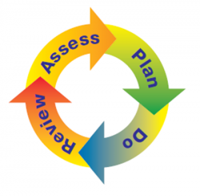
At Buckshaw we have a graduated approach in assessing and reviewing pupils’ progress towards outcomes that are tailored specifically for them. Particularly, pupils with an Educational Health Care Plan (EHCP). We always ensure that your child’s needs are kept at the centre of the process.
STEP 1 – ASSESS
- It is the teacher’s role to provide a clear evaluation of pupils’ needs.
- The teacher is supported by the SENDCO in gathering assessment information.
- Parent views and external advice also form part of the assessment.
STEP 2 – PLAN
- If it is agreed that a pupil requires SEND support then parents are informed.
- The class teacher and the SENDCO devise a plan agreeable with parents/carers regarding what support or interventions will be put in place, what the expected outcomes are, the impact and progress expected, alongside a review date.
- SMART targets are set: These are Specific, Measurable, Achievable, Realistic and Timely.
STEP 3 – DO
- Implementation of the plan.
- Teachers and teaching assistants work collaboratively to ensure pupils are making progress in meeting their targets.
STEP 4 – REVIEW
- On the date agreed, we consider the impact of any intervention against pupil progress.
- We then evaluate the effectiveness of the support.
STEP 5 – REPEAT
- The above process is then repeated to ensure continued promotions of our pupils’ learning and wellbeing.

- ARRANGEMENTS FOR SUPPORTING PUPILS MOVING BETWEEN PHASES OF EDUCATION AND PREPARING FOR ADULTHOOD
During the Summer term we allow our classes to move up to the next phase for one full day. This is to enable the children to feel confident and comfortable within their new classroom environment and with staff members that will be working with them. We also provide social stories for children who we feel would benefit from these. Children can take these home over the summer holiday break. They will consist of school times and routines, photographs of their teachers and new classroom environment. We support our year 6 pupils with the transition from KS2 to KS3. We invite the SENDCO from the child’s secondary school to their EHCP review.

- OUR APPROACH TO TEACHING PUPILS WITH SEND
At Buckshaw we believe all our pupils are entitled to Quality First Teaching (QFT). This is what QFT looks like at Buckshaw under the four dimensions of need.
COMMUNICATION AND INTERACTION
- Structured school and class routines
- Visual timetables
- Use of symbols
- Differentiated curriculum delivery
- Increased visual aids
- Pre-teaching of new concepts
- Post-teaching to ensure new concepts have been clear to follow
COGNITION AND LEARNING
- Differentiated curriculum
- Differentiated delivery
- Differentiated outcomes
- Increased visual aids
- Visual timetables
- Use of writing frames
- ICT devices to support learning
- Books with coloured pages to support pupils with dyslexia and/or dyscalculia
- Coloured instructions written on the board
SOCIAL EMOTIONAL AND MENTAL HEALTH DIFFICULTIES
- Whole school reward system
- Morning check-in with teachers and teaching assistants
- Morning diary for pupils to write about anything they wish to, in confidence
- Worry boxes in each class
SENSORY AND/OR PHYSICAL NEEDS
- Fidget toys
- Brain breaks and/or sensory breaks
- Pupils have access to playdough to strengthen their fine motor skills and wobble boards for their gross motor skills.
- Wobble cushions are provided for pupils who require additional support in maintaining a healthy posture whilst sitting at a table.
- Sensory diets

- ADAPTATIONS TO THE CURRICULUM AND LEARNING ENVIRONMENT
We continuously endeavor to make reasonable adjustments to allow all our pupils not only to access the curriculum but also to engage in their learning. Planning is differentiated to ensure it is accessible to all. Those children who have an EHCP work on their EHCP outcomes to allow for inclusivity. We ensure that speech and language therapy takes place in a quiet, acoustic friendly room (carpeted floor and low ceilings). Occupational Therapy provide equipment for children in wheelchairs, such as heightened tables in classes and chairs specifically designed to support posture. We also have radio aids in place for pupils with a hearing impairment.
The Hive:
We have made morning provision within KS2 that caters for children in years 3-6 that are currently working significantly below age-related expectations. These pupils may already have an Educational Health Care Plan (EHCP) in place, or may be on the assessment pathway. This is to ensure pupils can continue to learn at their own rate, with a tailored curriculum that allows all our children to gain a sense of achievement.
The Five a Day Principle:
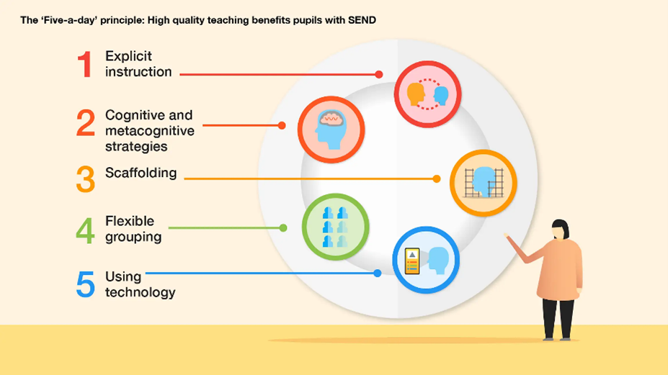
- ADDITIONAL SUPPORT FOR LEARNING THAT IS AVAILABLE FOR PUPILS WITH SEND
- Our Teaching Assistants (TAs) have been trained to deliver Talk Boost which is a speech and language intervention. They have also has training on delivery and implementation of colourful semantics.
- Our staff in EYFS and KS1 are also trained to deliver Early Talk Boost to our younger pupils who may be experiencing speech or communication difficulties.
- Additional brain breaks to support fine and gross motor skills.
- Wobble boards and cushions.
- Laptops and IPads for typing or using the speech to text tool.
- Specialist Teacher advice and referrals to appropriate bodies to gain additional specialist support when it is required.
- Books with coloured pages, coloured wipe boards and overlays.
- Social stories

- THE EXPERTISE AND TRAINING OF STAFF TO SUPPORT PUPILS WITH SEND.
Our SENDCO arranged ASD INSET training for all school staff on best practice. Our SENDCO also attended a social stories course and fed this back to all school staff. Our SENDCO regularly attends training and cascades the information to staff via staff meetings, training or via classroom support. We provided detailed information regarding IEPs and IBPs and how targets should be SMART:
- Specific
- Measurable
- Achievable
- Realistic
- Time-based.
At Buckshaw we strongly believe in ensuring all pupils have access to the same opportunities. This may mean some children require additional support, in addition to what is on offer for everyone else. This will then ensure equality.
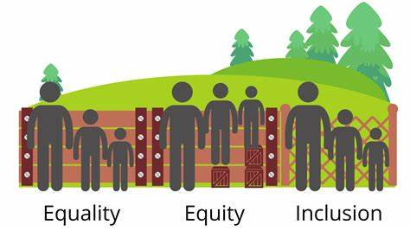
- SECURING EQUIPMENT AND FACILITIES
We work closely with the local authority to ensure equipment is secured as quickly and as promptly as possible. We work with occupational therapy teams, visually impaired teams and hearing-impaired teams. We strive to ensure that equipment is in place prior to pupils starting with us, or shortly thereafter.

- EVALUATING THE EFFECTIVENESS OF SEND PROVISION
Our whole school provision map details interventions and support each child on the SEND register is receiving. We look at pupil's attainment at the start of the intervention programme and then their attainment at the end of each term. This shows us clearly the effectiveness of the SEND provision in place.
SENDCO carries out weekly monitoring which involves discussion with pupils, books looks, lesson drop ins and learning walks.

- ENABLING PUPILS WITH SEND TO ENGAGE IN ACTIVTIES AVAILABLE WITH THOSE IN SCHOOL WHO DO NOT HAVE SEND
Our children are extremely lucky to attend such a versatile school. Children with SEND are treated equally and inclusivity is applied consistently. Steps we take to enable pupils with SEND to engage in activities available with those in school who do not have SEND are as follows:
- Mixed ability teams during lessons for peer support.
- Differentiation of learning allows all pupils to discuss the same topic.
- Access to after school clubs.
- Friendship groups and team games during playtime.

- SUPPORT FOR IMPROVING SOCIAL AND EMOTIONAL DEVELOPMENT
Our teaching assistants have had relevant training and are able to provide speech therapy to pupils in small groups. This allows them to make connections and form positive friendships surrounding a common theme. The views of our SEND pupils are continuously being collected through verbal discussions with teachers and teaching assistants. This may be on a 1:1 basis or within a group. Our family support worker and learning mentor provides 1:1 sessions to support pupils in engaging with their own emotional development and ensuring they flourish with positivity about themselves. As we are such a versatile school, SEND is open to discussion at every avenue with all pupils. This allows pupils to support one another in a positive manner. For our younger pupils we are beginning to incorporate versatile books into their reading library. These books portray children in wheelchairs to those that may wear hearing aids. We use various sources to show the children how a neurodiverse person might perceive the world. We have a trained Emotional Literacy Support Assistant (ELSA).
- WORKING WITH OTHER AGENCIES
Once we identify a child may have SEND we first ensure the plan, do, assess, review process is completed at least on three occasions to get a holistic understanding of teaching and learning styles that a pupil may have responded and engaged with to those that they did not engage with. Once we have exhausted QFT strategies we would then move onto wave 2. In-house Interventions will be put into place to support the pupil further. If we do not feel at this stage that a pupil is making adequate progress we will then move onto wave 3 and work alongside other agencies in order to support the teaching and learning of our SEND pupils. Our family support worker, works closely with families in providing pastoral care. She has a good rapport with our families and puts referrals in to places such as:
- Children and Families Well-Being Service (CFWBS)
- Barnardos
- Child Action North West (CANW)
- Multi agency work between health professionals – clinical psychologist, learning disability team, paediatrician, CAMHS, mental health team
- Referrals to nurture group – looking at emotional well-being such as anger, stress, anxiety etc. A box will be provided with the relevant tools for pupils to use at home and in school.
- Children in year 6 – transition group – run by children and families well-being service.

- COMPLAINTS ABOUT SEND PROVISION
The school has a complaints procedure which applies to complaints about SEND provision. This can be found on the school website under the Important Documents tab. Namely, Parental Complaints Policies and Procedures.
- CONTACT DETAILS WITHIN BUCKSHAW FOR RAISING CONCERNS

- Mrs Sarah Price – Headteacher: head@buckshaw.lancs.sch.uk
- Mrs Laura Heyes – Deputy Headteacher: l.heyes@buckshaw.lancs.sch.uk
- Mrs Ikram Albustany – SENDCO: i.albustany@buckshaw.lancs.sch.uk
- SEND Governor: johnmcandrew95@hotmail.com

- LANCASHIRE LOCAL OFFER
https://www.lancashire.gov.uk/children-education-families/special-educational-needs-and-disabilities/
The SEND local offer is:
- Information, advice, support and services.
- Provided by education, health, Lancashire County Council (the local authority) and voluntary organisations.
- Local to Lancashire.
- For children and young people with special educational needs and disabilities (SEND) aged 0-25.
- If you'd like to receive updates about, SEND in the local area you can receive a free newsletter, by joining the FIND database: https://www.lancashire.gov.uk/children-education-families/special-educational-needs-and-disabilities/getting-help/family-information-network-directory/ or connecting to the local offer on Facebook: https://www.facebook.com/LancashireLocalOffer/

- LINKS WITH OTHER POLICIES AND DOCUMENTS
- Accessibility Plan
- Supporting pupils with medical conditions
- SEND policy
- Behaviour policy

